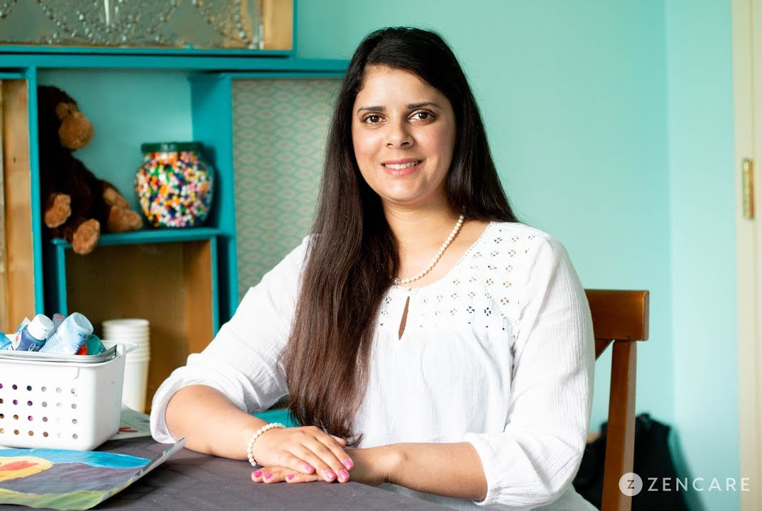
How I can help

School-based counseling and support services

at school name here
Life can be stressful and difficult to manage. As a therapist, I offer a safe and non-judgemental space where individuals can talk and be listened to. I help individuals acquire skills and navigate through their strengths.
Together, we can create a plan to help you achieve your goals. I will help you create a toolbox that you can use throughout your life. I use evidence-based practice in treatment. I primarily use Cognitive behavioral Therapy, motivational interviewing, and floor time with children.

logo

Agency Name
phone 000-000-0000 • fax 000-000-0000
00 Street Street, City, ST 00000
www.agencyurl.com
Como puedo ayudar

Firstname Last
Licensed Clinical Social Worker
Agency Name
Hablo, leo, y escribo en español. La vida puede ser estresante y dificultosa para manejar. Como terapeuta, ofrezco un lugar seguro y sin juzgar donde individuos pueden hablar y ser escuchado. Ayudó a individuos adquirir habilidades y navegar sus áreas fuertes.

